Part1

import java.net.\*;  
public class IP {  
 public static void main (String[] args) {  
 try {  
 InetAddress address = InetAddress.*getByName*(args[0]);  
 System.*out*.println(address);  
 }  
 catch (Exception ex) {  
 System.*out*.println(" Can't find the IP ");  
 }  
 } }

Part 2

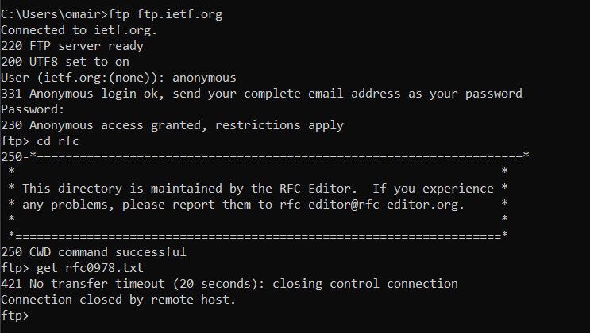

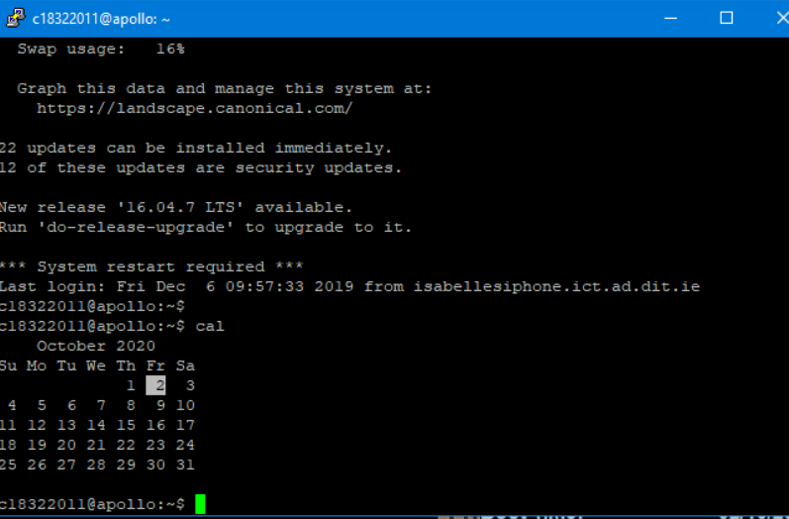

Part 3

import java.net.\*;  
class IP {  
 public static void main(String [] args ){  
 *testProtocol*("http://www.tudublin.ie");  
 *testProtocol*("https://www.tudublin.ie");  
 *testProtocol*("ftp://tudublin.ie");  
 *testProtocol*("smtp:tudublin.ie");  
 }  
  
 public static void testProtocol(String url){  
 try {  
 URL u = new URL(url);  
 System.*out*.println(u.getProtocol() + " is supported");  
 }  
 catch (Exception ex) {  
 System.*out*.println(url + " is not supported");  
 } } }